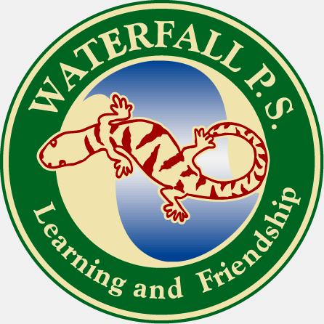
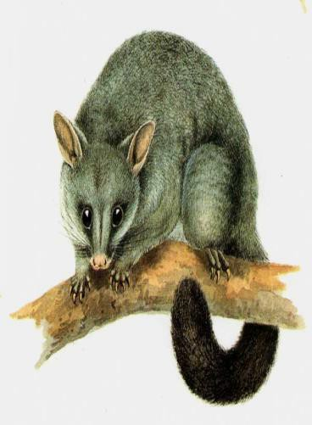
Waterfall Public School
15 McKell Avenue
Waterfall NSW 2233
9520 9638 F: 9548 1238

Term 3,Week 9, 2018
Principal’s Report

Report on Weeks 6-10

It appears that Term 3 has just flown by, with our students engaged in many wonderful learning programs to support their success at school.
During Week 6, students participated in the next session of the Native Bird Study project, displaying increasing knowledge of the native birds who inhabit our local environment.
A special thank you to the Royal National Park Educational Environment Centre and their principal, Ms Julie Gallan, for collaborating with school staff for this project.

Students also began participation in the 4 week YMCA Y-Pep program, developing understanding of positive relationships.

During Week 7, selected students in Year 6 attended lessons at Wollongong Art Gallery, we finalized our School Public Speaking Championships and our successful Champion School Spellers, Rachel, Johnathan and Evie performed wonderfully in the Regional Spelling Bee.

We also experienced the most amazing “white out” at school with a huge hail storm on Friday afternoon, leaving our school a snowy wondrous sight! Waterfall’s white out was the lead story on all the Sydney news channels that night.

During Week 8 we were joined by Sarah Toedtler from University of Wollongong who spoke to 3/6 students about their project brief for the Illawarra Science Fair in November.

Our successful School Public Speaking Champions, Johnathan, Rachel and Mark respresented us admirably at the Zone Public Speaking Championships.

During Week 9 students enjoyed their second Yoga class with Laura, displaying increasing flexibility and balance as they learnt new skills.

And finally to our upcoming Week 10..

Celebration of Learning for National Numeracy and Literacy Week.

The students will be engaging every day in exciting Numeracy and Literacy activities as described on the timetable sent home last week.

** We hope to see all our families friends and community members join us at 11.30 next Thursday 27th September for our gala concert, open classrooms, Book Fair (bring your gold coins -$4 per book) and BBQ lunch.**

A special personal thank you from myself, as principal, to all our wonderful school staff (Jennifer Porter, Kirsty Maddocks, Vicky Reid, Christine Westbrook, Chris Rasborsek, Elyse Hardiman, and volunteer tutor, Karen Wood) who parents may not know , work above and beyond their duty role to ensure our students have every opportunity to succeed in a stimulating challenging learning environment, and are mindful that the students have opportunities to learn beyond the school gate, through excursions, collaborations with other schools and visiting specialists.

The immense workload and availability to parents by staff in a small school is far beyond that of staff in other schools, and I acknowledge their professionalism and the impact this has on their families.

I also wish to thank and acknowledge our hard working P&C who work tirelessly to support our school in so many generous and kind ways.

As this will be our last newsletter for the term we wish all our families a safe relaxing school vacation and look forward to seeing all our students and staff back at school refreshed and ready for an exciting challenging term of learning in Term 4.

Best Regards,
Penelope Passmore
Principal

***************SCHOOL NEWS ITEMS***************

ILLAWARRA SCIENCE FAIR
Class 3-6 will be participating in the Illawarra Science Fair on Wednesday 28th November. Students have chosen their team (or chosen to work solo) to investigate a scientific questions. Detailed information will be sent home shortly. Students are to work on their projects at home but will also have school support, as I will supervise and make a space available after school for students to put their presentations together. We are very excited about the Fair!

LUNCHES
As the warmer weather approaches many students like to bring different types of lunch foods. Tinned tuna is not permitted at school due to the danger from cut metal. Parents are asked to decant the tuna into a re-sealable container.
Students bringing tubs of yoghurt are asked to bring their own spoon, as the limited staff supply of spoons are not often returned.
We seek your support in developing independent organizational skills with the students in managing their lunch supplies.

BAND
It is disappointing to note we still have a number of families with outstanding band fees, for Term 1-3.
This money is utilized to employ Miss Hardiman and for servicing our instruments ($150 per instrument service).
Please ensure payment is made by end of Term or students position in the band may be reviewed. The school does not receive any Government funding to conduct our band program.
Our band program is the cheapest in the District and much cheaper than private tuition.
Thank you for your anticipated support in paying overdue band fees promptly.

INVICTUS GAMES
Payment of $40 per child (class 3/6 only) is due on the 19th October for each family who has signed for their child/children to attend the Games.
The school is already subsidizing the tickets and providing transport . We seek your support in this matter.

BUSHFIRE NOTE
This week all families were sent a copy of Waterfall Public School’s Bushfire Plan.
We ask you to read the plan and keep it somewhere safe.
We also ask that you return the acknowledgement slip to help us ensure all families know and understand the plan.
This is very important, given the increased bushfire concerns with the upcoming fire season

CONCERNS AND COMMENTS

It is always disappointing to the hard working staff and myself, when parents choose to voice their concerns about a school issue on public social media sites.

This does not demonstrate the school value of respect or acknowledge that a conversation with school staff could easily address the concern.

We value our community’s comments and suggestions, both negative and positive, as we build our school culture of continual school improvement, so consider approaching the school for a response before voicing concerns on public media.

Term 4 2018
Monday 15th October
Students and staff return

Tuesday 16th October
Choir Auditions
Australian Youth Choir

Wednesdy 24th October
Day For Daniel (wear red)
K-6 Assembly

Thursday 25th October
School Staff- External Validation Team visit to school.

Friday 26th October
Class 3-6 to Invictus Games

Monday 29th October
P&C meeting 7pm Library

Tuesday 30th October
K-6 excursion to the Australian Museum
(Opal cards)

Wednesday 31st October
GrandFriends Day 10.00am

Thursday 1st Nov
Year 6 to Leadership By The River, Menai

Outdoor Classroom Day

Monday 5th Novembrer
HHS to visit Year 6 Transition Meeting

Wednesday 7^{th November}
K-2 AFL DAY Heathcote Oval
(Opal card)

Friday 9th November
Centenary of Armistice Commemoration Assembly
ALL WELCOME 10.30am

MONDAY 12th November
Kinder Orientation 1

Wednesday 14th November
Stanwell Park K-6
Kite Day-Lawrence Hargraves event
(Opal card)

SATURDAY 17th November
P&C Shopping rip Fundraiser
MONDAY19th November
Kindergarten Orientation 2

WEDNEDAY 21st November
Pet Education visit K-2

Monday 26th November
Kindergarten Orientation 3

Tuesday 27th November END OF YEAR EXCURSION
K-6 to the city

Wednesday 28^{th November}
Illawarra Science Fair 3-6

Monday 3rd December
K 2019 Parent meeting
7pm P&C

Wednesday 5th December
Last K-6 Assembly

Thursday 13th December
Presentation Day 9.30

Friday 14th December
School reports home

Tuesday 18th December
Year 6 Farewell 5.45-8pm, 3-6

Wednesday 19th December
Last day students

